

The Ministry of Health and Social Welfare

national management information systems policy

June 2009

Table of contents

Acknowledgements………………………….. ……... ii
1. Preamble ……………………… i
2. Definition of HMIS in Liberian Context 1
3. Mission, Vision, Values, Goal, and Objective(s) 1
4. The Guiding Principles 2
5. Recording and Reporting System 2
6. Data Transmission and Capture 3
7. Data Analysis, Reports and Feedback 3
8. Data Repository 3
9. Data Security 4
10. Data Quality Assurance 4
11. Information Use 4
12. Confidentiality 4
13. External Collaboration 4
14. Financing of HMIS 5
15. The Role of the Liberia Institute of Statistics
and Geo-Information Services (LISGIS) 5
16. The Role of the Monitoring, Evaluation and Research Division 5
17. Vital Registration…………………………………………………. 5
18. The Role of Counties Health Team 5
19. The Role of Health Facilities 6
20. The Role of Community Health Volunteers 6
21. The Role of the Private Sector 6
22. The Role of NGO 6
23. Design of HMIS 6
24. Strategic Plan 6
25. Revision of policy, plan and strategy 7

Acknowledgements

On behalf of the senior management of the Ministry of Health and Social Welfare (MOH/SW), I would like to whole heartedly extend our heartfelt thanks and appreciation to all institutions and individuals that made the development of the Health Information Management System (HMIS) Policy possible.

While it would be impossible to list each contributor by name, I would like to mention some key organizations without whose support the development of the HMIS Policy would have been impossible.

The BASICS Project with funding from USAID was instrumental in fielding the consultants who worked with the Ministry of Health and Social Welfare and other health partners to develop and refine this document. In addition to making inputs in the finalization of the Policy, a number of our health partners contributed significantly during all stages of the policy development; among these are Merlin and the Health Information system Project (HISP) of South Africa.

Again, I sincerely convey my gratitude to all individuals and organizations that contributed to putting together the various strategic pieces that made up the HMIS policy.

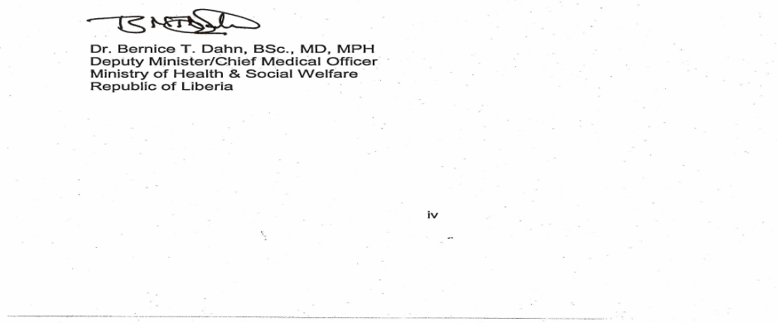

1. Preamble

National Health Policy 2007 identifies the Health Management Information System as one of the essential building blocks of the national health system and thus places it on top priority. This document provides overall policy guidelines for designing, developing, and operationalizing Health Management Information System in the country.

2. Definition of HMIS in Liberian Context
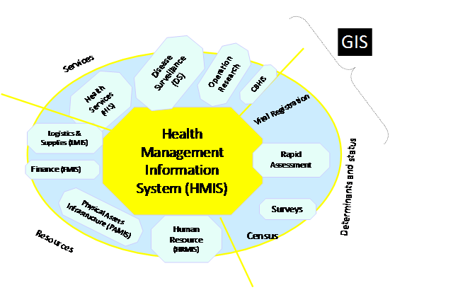
An information system, consisting of various sub-systems, specially designed for data collection, processing, reporting, and use of the information necessary for improving health service effectiveness and efficiency through better planning and management at all levels of health care delivery systems. It is diagrammatically explained in the figure below.

3. Mission, Vision, Values, Goal, and Objective(s)

Mission

Health service plans and management decisions are fully evidence based

Vision

To become capable to generate, analyze and feed required information in a timely manner to all those involved in planning and management of health services

Goal

Contribute to evidence based decision making in the health sector

Objectives
- To generate quality information in a timely manner
- To ensure the use of information in planning and management of health services

3

4. The Guiding Principles

Adherence to International Standards
This policy endorse the adaptation of HMIS framework to attain the international standards set by the Health Metrics Network (HMN), the first global health partnership for developing and strengthening of health information system in low and low-middle income countries. HMN seeks to achieve standardization by adopting and adapting global health information standards that are aligned to broader efforts to improve the availability and quality of statistics.

Equity, Quality and Social Justice
The policy supports the establishment and maintenance of a simple, coherent, scientifically sound and easily understandable information system tracking the degree of achievement of the MOHSW objectives at all levels, taking into accounts the national values of universal coverage, equity, quality and social justice.

Accountability
The policy recognizes the need to establish clear structures in support of the system and accountability for results by well trained and motivated personnel.

Communication
The policy strives to build a system of effective communication, using appropriate technology and feedback and dissemination to all stakeholders.

Decentralization
Focus is shifted from data collection to transforming data into information for management. A holistic approach that seeks for unified and decentralized HMIS will be operated and only usable information will be collected.

Inclusiveness
All data as much as it is practical, will be disaggregated by gender, age groups, geographical areas and social income groups.

5. Recording and Reporting System
- Service records are by far the biggest primary source of health data. All providers attending individual seeking services will undertake to record essential information on the prescribed format.
- All registers in various programs in the Ministry of Health and Social Welfare will be developed in consultation with the Monitoring, Evaluation and Research Division to facilitate reporting and avoid duplication. To maintain efficiency, all the registers will have unique identification numbers.
- All health and social welfare activities will be recorded in relevant paper or electronic registers at the time of transaction of the business.
- In cases of an out break as will be defined by specific programs policies, notification of the target disease will be submitted on daily basis. Zero case or death notification will be practiced as determined by MOHSW from time to time.
- All recorded health and social welfare activities will be reported in line with the existing regulations which will be updated from time to time by the Monitoring, Evaluation and Research Division.
- All inpatient activities and outcomes will be recorded in line with ICD-10, the International statistical Classification of Diseases and related health problems Version 10.
- The MOHSW will maintain and update a register of all health facilities of care delivery points and maintain a system of supervision.

6. Data Transmission and Capture
- CHTs will maintain an efficient database for all health and social welfare activities in the areas under their supervision. Data within the counties will be collected, edited, coded, entered using a standardized software as devised by Monitoring, Evaluation and Research Division in consultation with IT Department.
- All CHTs will submit an electronic data to Monitoring, Evaluation and Research Division on a monthly basis in order to update HMIS central repository.

7. Data Analysis, Reports and Feedback
- The Monitoring, Evaluation and Research Division will develop and publish guidelines with templates for essential data analysis at all levels and conduct relevant training in this respect.
- All levels of health and social welfare system will conduct essential analysis of their data regularly generating necessary information for their core business.
- The Monitoring, Evaluation and Research Division will aggregate and analyze the national health and social welfare data annually and provide a comprehensive report for all stakeholders. All reports will be available through web based HMIS portal.

8. Data Repository
- All facilities will be responsible for safe storage and easy retrieval of all records under their responsibility and in line with GOL archives regulations.
- All records in electronic formats will be mirrored in second server and also stored in CD-ROMS and safeguarded.
- Until otherwise regulated, records of patients who die in health facilities will be kept for ten years.
- All other patients’ records and registers will be disposed every five years after closure.

9. Data Security
- All health data from health and social welfare system will be shared with all stakeholders on predefined reporting frequency and format through HMIS portal
- Access to sub-system specific databases and central repository will be restricted to authorized individuals only.

10. Data Quality Assurance
- Monitoring, Evaluation and Research Division will develop and publish guidelines on data management to ensure standardization.
- The MOHSW will implement skills development programs and regular training on data management and benchmarking for all levels of service.

11. Information Use
- The Monitoring, Evaluation and Research Division will create demand and promote use of information through timely supply of accurate and easily understandable information.
- The Monitoring, Evaluation and Research Division will regularly publish the health information on its portal to enhance access by individual researchers, research institutions and the public at large. Limited hard copies will be available to strategic partners who have no means to download and print.

12. Confidentiality
- The publication of the information from MOHSW will be guided by the provision of Statistics Act and the Public Health Act and any other existing regulations on privacy. In all HMIS operations, efforts will be exercised to protect the clients’ rights without compromising safety and knowledge development.
- Health workers who have privileged access to patient’s records will be accountable to maintain the highest level of confidentiality and ensure that shared confidentiality is only practiced in the interest of the patient.

13. External Collaboration
- The Monitoring, Evaluation and Research Division in MOHSW will ensure that data and information required for defined global reporting is collected in compatible formats and submitted to relevant authorities.

14. Financing of HMIS
- The MOHSW in collaboration with partners will mobilize financial resources through appropriate and sustainable means to enable all the levels of health care to produce high quality health and social welfare information.
- Resources will also be sourced to develop staff skills and provide critical inputs to convert data into meaningful information readily available for decision making.

15. The Role of the Liberia Institute of Statistics and Geo-Information Services (LISGIS)
More robust data sources like the Census, Demographic Health Survey or House Hold Budget Surveys will continue to be generated with active participation of the MOHSW but the main responsibility will remain with LISGIS.

16. The Role of the Monitoring, Evaluation and Research Division
- The Monitoring, Evaluation and Research Division will provide leadership for health and social welfare data management in close collaboration with other strategic partners including LISGIS. The Health Sector Coordination Committee will act as “HMIS Steering Committee” and strengthen this function. HMIS core members will be identified and Technical Working Group(s) with expertise in different information sub-systems will be formed to design, develop, and operationalize the HMIS.
- The Monitoring, Evaluation and Research Division will ensure unified and timely data collection, collation, processing and dissemination.
- To maximize efficiency, the Monitoring, Evaluation and Research Division will develop strategic options for human resource development in data management and participate in operational research.

17. Vital Registration
The MOHSW will strengthen registration of vital events and processing the birth and death data.

18. The Role of Counties Health Teams
- The counties will be the centre for data management. The team will ensure county data collection, capture and analysis for decision making. A copy of the analysis report will always be shared with county health stakeholders including NGO, Civil Society groups and the MOHSW.
- The team will also be responsible for the training and supervision of the facility level health personnel and report regularly to the Monitoring, Evaluation and Research Division.

19. The Role of Health Facilities
- All Hospitals, Health Centers and Clinics (governmental and nongovernmental) will maintain registers and records of all health and social welfare activities as prescribed by the Monitoring, Evaluation and Research Division of MOHSW. The health facilities will transcribe information from these registers and records and report regularly to the CHT. Essential analysis conducted at this level will be shared with respective health facility management committee, local authorities, and supervising levels within the MOHSW.
- All health facilities will be responsible for efficient records management at their level and ensure easy accessibility, confidentiality and retrieval.

20. The Role of Community Health Volunteers
The community health volunteers will maintain registers recording daily activities and reporting regularly to supervising health facilities.

21. The Role of the Private Sector
- Notify at least all diseases under surveillance and total number of cases seen in each month.
- Private health facilities not complying with reporting requirements will not be accredited.

22. The Role of NGO
- The MOHSW will endeavor to work together to build a unified health and social welfare data collection, collation, analysis and publication system.
- In spirit of partnership, NGO will motivate all health facilities under its umbrella to adhere to national health and social welfare data management system.
- In collaboration with MOHSW and other partners, NGO will mobilize resources for HMIS, and ensure efficient data management in all its health facilities.

23. Design of HMIS
Overall design of the HMIS including constituents, interface between systems, information flow will be elaborated in the strategy.

24. Strategic Plan
A long term strategic plan complemented by an annual action plan will be developed to guide implementation of these policy guidelines.

25. Revision of policy, plan and strategy
The Monitoring, Evaluation and Research Division will ensure that the HMIS policy, design and strategy and their implementation are regularly reviewed to maintain relevancy and appropriateness to the broader objectives of the MOHSW.

